June 2022

From the theater stage to the recording studio - 2 songs by Nathalie Weider with Goran Kovačević

The Swiss singer Nathalie Weider has released two songs together with accordion player Goran Kovačević. The songs are available under the title «Akkordeon-Session» on Bandcamp.

The two artists had known each other by name for a long time. They worked together for the first time in 2020/2021 on the occasion of Nathalie's engagement at Zentrumbühne Bottighofen in the musical theater «Don Camillo und Peppone», for which Goran was the musical director. This was not to be the last collaboration: The singer and songwriter wanted to record two of her songs absolutely reduced and intimate in an accordion version. No sooner said than done and the two were creative together in the recording studio: The two songs «Wiesbaden (So nah)» and «Tür» are available from June 10, 2022 as «Akkordeon-Session», for the time being and in this combination exclusively on the platform Bandcamp.com.

The songs describe two very different personal stories of Nathalie Weider. What they have in common is the dynamic of closeness and distance - a dynamic that Goran Kovačević's melancholy accordion playing could not have musically captured more aptly.

www.nathalieweider.ch
www.nathalieweider.bandcamp.com/album/akkordeon-session

1209 characters

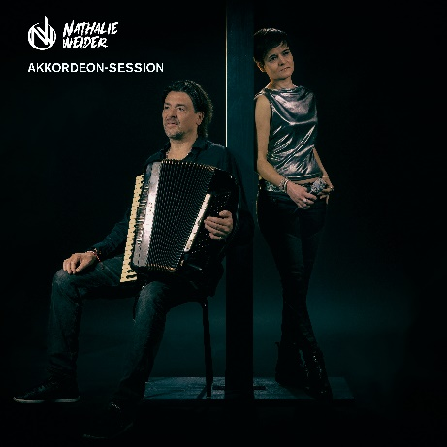
Pictures (photographer: Raffael Soppelsa)

Cover picture «Akkordeon Session» by Nathalie Weider

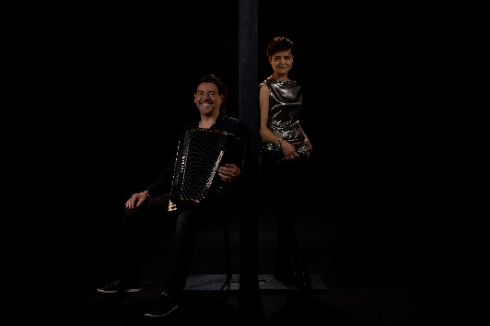
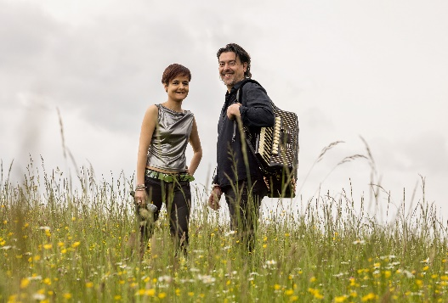

Press pictures Nathalie Weider & Goran Kovačević

Download Area for media representatives for song files, high resolution pictures and further information & credits: https://www.nathalieweider.ch/akkordeon-session
Nathalie Weider is available for interviews and promo appointments.
Media contact: presse@nathalieweider.ch

